Sent in Poverty, Sent in Power
Sermon by Jan Wiersma
Community Presbyterian Chuch - Rochester, Minnesota
6th Sunday after Pentecost - July 4, 2021
Texts: 2 Corinthians 12:2-10, Mark 6:1-13

2 Corinthians 12:2-10
I know a person in Christ who fourteen years ago was caught up to the third heaven—whether in the body or out of the body I do not know; God knows. And I know that such a person—whether in the body or out of the body I do not know; God knows— was caught up into Paradise and heard things that are not to be told, that no mortal is permitted to repeat. On behalf of such a one I will boast, but on my own behalf I will not boast, except of my weaknesses. But if I wish to boast, I will not be a fool, for I will be speaking the truth. But I refrain from it, so that no one may think better of me than what is seen in me or heard from me, even considering the exceptional character of the revelations.
Therefore, to keep me from being too elated, a thorn was given me in the flesh, a messenger of Satan to torment me, to keep me from being too elated. Three times I appealed to the Lord about this, that it would leave me, but he said to me, “My grace is sufficient for you, for power is made perfect in weakness.” So, I will boast all the more gladly of my weaknesses, so that the power of Christ may dwell in me. Therefore I am content with weaknesses, insults, hardships, persecutions, and calamities for the sake of Christ; for whenever I am weak, then I am strong.
Mark 6:1-13
Jesus left the place where he had healed a hemorrhaging woman and raised a little girl from her deathbed, and came to his hometown, and his disciples followed him. On the sabbath he began to teach in the synagogue, and many who heard him were astounded. They said, “Where did this man get all this? What is this wisdom that has been given to him? What deeds of power are being done by his hands! Is not this the carpenter, the son of Mary and brother of James and Joses and Judas and Simon, and are not his sisters here with us?” And they took offense at him. Then Jesus said to them, “Prophets are not without honor, except in their hometown, and among their own kin, and in their own house.” And he could do no deed of power there, except that he laid his hands on a few sick people and cured them. And he was amazed at their unbelief.
Then he went about among the villages teaching. He called the twelve and began to send them out two by two, and gave them authority over the unclean spirits. He ordered them to take nothing for their journey except a staff; no bread, no bag, no money in their belts; but to wear sandals and not to put on two tunics. He said to them, “Wherever you enter a house, stay there until you leave the place. If any place will not welcome you and they refuse to hear you, as you leave, shake off the dust that is on your feet as a testimony against them.” So they went out and proclaimed that all should repent. They cast out many demons, and anointed with oil many who were sick and cured them.
Keep these words in your heart. The Lord is our God, the Lord alone. Thanks be to God.
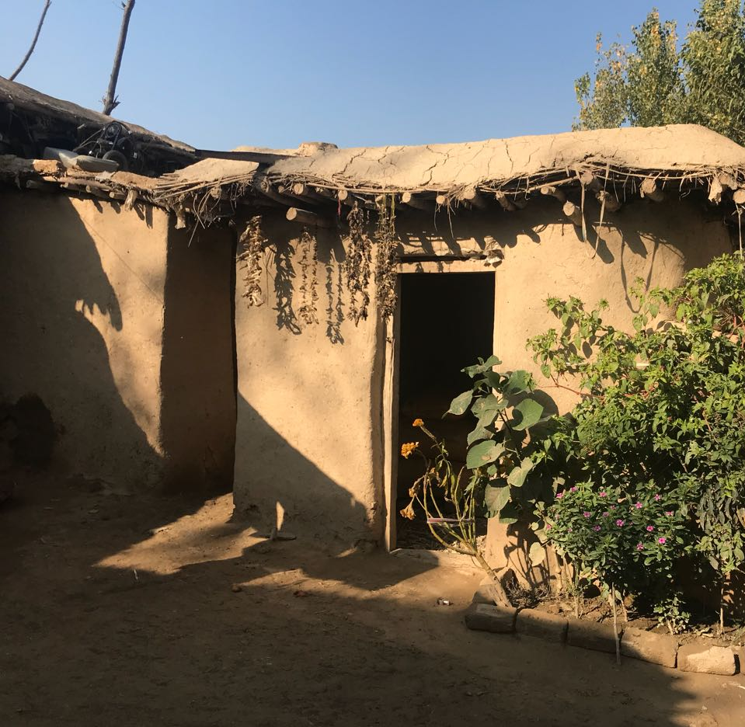
Jesus, the one we call our Savior, was born to poverty, not to privilege. He was born in a stable, not in a palace, to poor parents, not rulers. Maybe that’s why the people in his hometown didn’t trust his power: he was just one of them. Ordinary. Mary’s son. His acts of power offended them, and their lack of faith limited his power. And he was amazed by their unbelief. But he passed power on to his disciples. He sent them in poverty, too - no food, no money, no extra clothes. But he also sent them clothed in power, to do the same things he did. Curing, healing, saving tormented souls. But only where they were trusted and wanted. And he sent them two by two, not alone.
I want to think a little bit about poverty and power today. And how we wear them.
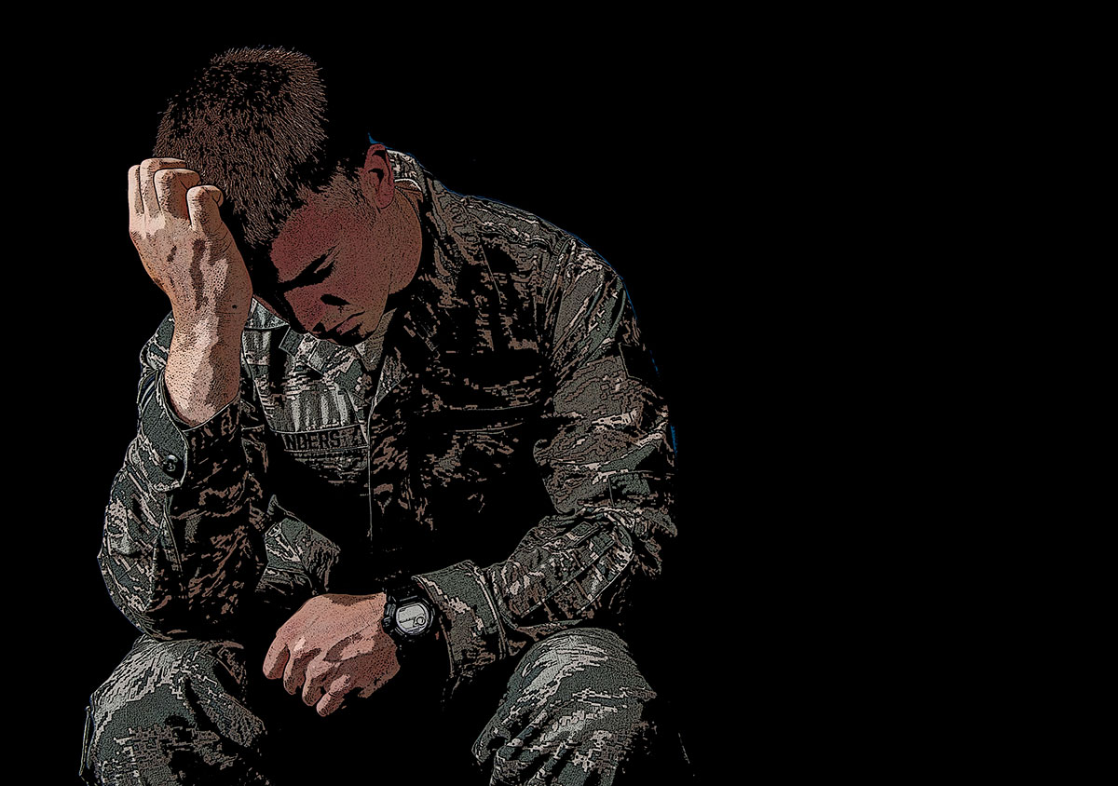
Please pray with me. God, help us to see ourselves clearly today. Show us without doubt where the source of our power lies: in you and you alone. Amen
A few years ago, a new neighbor moved in across the street from us. Tim’s entry into our quiet neighborhood was rocky. His dogs ran loose, getting into trouble. Roommates came and went. Some seemed to be selling drugs. A couple of times a week, the police showed up. Once we asked an officer what was wrong and if we could help. He replied, not unkindly, “Your neighbor has mental health issues. Best to leave him alone.” We didn’t, but Tim mostly kept to himself, anyway, just working, often in the dark, on a yard that just stays messy -- except for the flagpole with two flags: the Stars and Stripes, and another below: maybe the POW-MIA one, or one that reads “All gave some; some gave all.” This summer, another friend showed up to help, working twelve hours a day in the heat. We stopped to talk to him: “I’ve known Tim since we were this high,” he told us. “I try to help. He can’t seem to get things together. People take advantage of him because of his pension.
“He just hasn’t been the same since he came back from Iraq.”
Our country sent him off in power, trained and armed. The war sent him back in poverty. Not lacking money. But poverty of spirit. Alone, troubled, trying and failing to fit in.
I remembered a neighbor from my childhood. He lived with his parents across the street, though he looked as old as my father. On nice days he’d shuffle slowly up and down the block. “Best to leave him alone,” our parents said. I never saw him talk to anyone at all. He was just...different. “Shell shock,” they called his condition then. Who had heard of PTSD then? No one.
Our country sent him off in power. The war sent him back in poverty. Not unhoused or unfed, but impoverished in spirit. Harmless. But scary to children who were told to “leave him alone.”
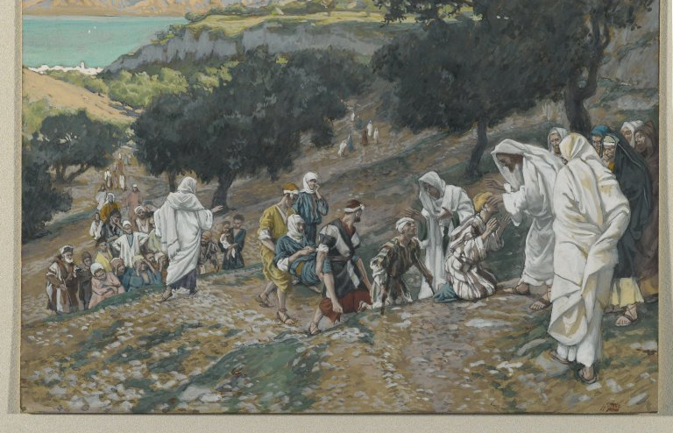
I love my country. I value its benefits and cherish its ideals, even though I know we don’t always live up to them. I love my way of life. I love my healthy standard of living and I love my safe, friendly neighborhood. But I don’t always feel comfortable with the way we Americans wear our power and our privilege. Our independence.
There’s a reason that God sent Jesus to poor, ordinary parents, dark-skinned members of an oppressed nation. Neither free nor independent. There’s a reason God sent him clothed with power that came from within, not from his position in society. Because he was one of them, other poor, downtrodden folks flocked to him for hope, for healing. Except those from his own hometown, who doubted him.
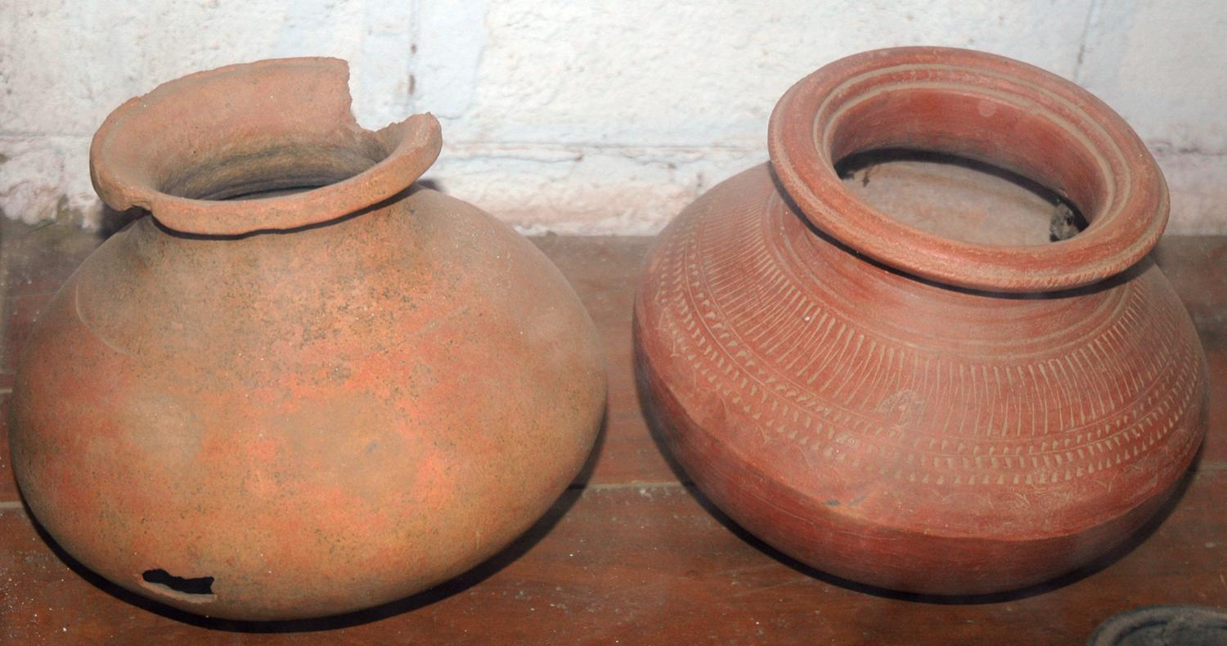
There’s a reason that Jesus sent his own disciples in poverty. Someone who has no money, no food, has to rely on others just to eat, to live. It’s the difference between being independent and inter-dependent. The apostle Paul said it many times in his letters to the people who welcomed him and his message of Jesus’ saving love: “We hold this love, this treasure, in jars of clay - fragile containers - so we know clearly that this extraordinary power belongs to God, and not to us;” and elsewhere: “I boast of my weakness, not my strength, so that the power of Christ may dwell in me...for whenever I am weak, then I am strong;” and again: “Even your faith is not your own; it is God’s gift to you.” The disciples returned to Jesus, amazed at what they could do in the power of his name.
When we are sent in poverty, we know for sure, everything we have is God’s gift - even one another. When we are comfortable in our wealth, in our independence, we believe in ourselves rather than in God. Believing ourselves to be good, we remain ignorant of our complicity in unjust systems. ‘God has communicated in a million ways that “I am your power,” but we do not believe and trust what we cannot see or prove. Instead, we bow down to lesser kings (like institutions, nations, wars, ideologies) that we can see, even when they serve us quite poorly.’ (Richard Rohr). God must be amazed, sometimes, at our unbelief in our true source of power.
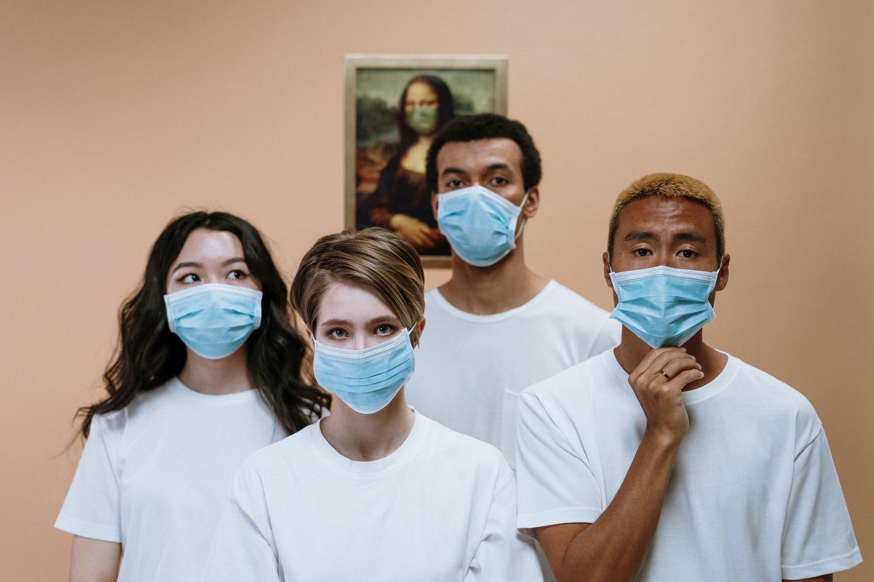
If this past season of covid has taught us anything, it has taught us that alone, we are powerless, helpless. We are not as independent as we thought; we have had to rely on others to mask for their protection and ours, to provide medical care even when they were overwhelmed, to discover causes and develop vaccines. We have seen infection rates go down when people accepted vaccination. We have seen cases soar where vaccine is rejected or not available. We are one world, one interwoven web of connection. We’ve been humbled, we’re poorer in some ways. I hope so - because when we are weak, then we’re strong. Jesus said somewhere, “Blessed are the poor in spirit; theirs is the kingdom of God.” What is God’s kingdom but a family where all are related, not by birth but by love? What is God’s kingdom but a world where all care for all, a place not ruled by a human king, but a kin-dom of equals blessed by God?
Why not celebrate our interdependence today, this Fourth of July, by recognizing and thanking someone you depend on for your health and wellbeing? Maybe an aide, or a nurse, [maybe a co-worker], maybe a teacher or a coach. Maybe a repair person or a delivery person or garbage collector. Maybe a disabled vet, who can’t quite seem to fit in. Don’t just leave her or him alone; acknowledge them, thank them for their work and sacrifice. We can wear our power and privilege with humility; and wear our common poverty with dignity. Everything is gift. TBTG
Creator God, knowing your unmerited grace,
We pray for courage to act faithfully, according to your will.
Give us courage to speak against injustice, to build collective power that acts in solidarity with those who have suffered the most, and to abolish unjust systems.

God our strength, give us the courage to dream with you
and to envision your kingdom - your kin-dom - on earth.
As we seek to move toward your vision for creation restored,
We pray for our neighbors across the nation and around the world.
We pray for comfort for those in grief, especially in Surfside, Florida;
Healing for the sick, especially those suffering from covid;
Binding up for the broken-hearted; Nourishment for the hungry;
Soothing of souls for the afflicted. Solidarity for the marginalized.
Just as we depend on you, help us depend on one another.

